**Building a Sentence**

In order for us to understand what we read in English we must know the English words, but it is also very important to see the structure of the whole sentence and **read the words in ‘packages’ or ‘units’ of meaning**, a little like reading a mathematical equation:

**(a + y) (b + x) = (c – y).**

We must also see how one sentence relates to another and how they are put together to make a paragraph. The paragraphs are linked together to make **one cohesive piece of writing**.

**Four basic English sentence structures:**

A. subject + verb (intransitive): (**The boy**) + (**walked**).

B. subject + verb (transitive) + object: (**The boy**) + (**walked**) + (**the dog**).

C. subject + verb + complement (**The boy**) + (**is**) + (**a student**).

D. subject + passive verb (**The boy**) + (**was loved**).

**We can add more information to these sentences, but the structure never changes:**

1. subject + verb:

i) (**The** dark-haired **boy**) + (**walked** quickly).

Adverb

Adjective

**Which boy walked? The dark-haired boy** walked.

**How did he walk?** He walked **quickly**

ii) (**The** dark-haired **boy** [who lived {on this street}]) + (**walked** quickly {through the park})

Prepositional phrase

Adjective clause:

**Clause: subject + verb**

(who) + (lived) + {on this street}

prepositional phrase

**Which dark-haired boy?** He was the one **[who lived on this street]. [adjective clause]**

**Where did he live?** He lived **{on this street}. {prepositional phrase}**

**Where did he walk?** He walked **{through the park}. {prepositional phrase}**

**The adjective, the adverb, the clause, and the prepositional phrase** each answers a specific question.

**The clause is one whole unit.** Each individual word has no meaning on its own.

**The phrase is one whole unit.** Each individual word has no meaning on its own**.**

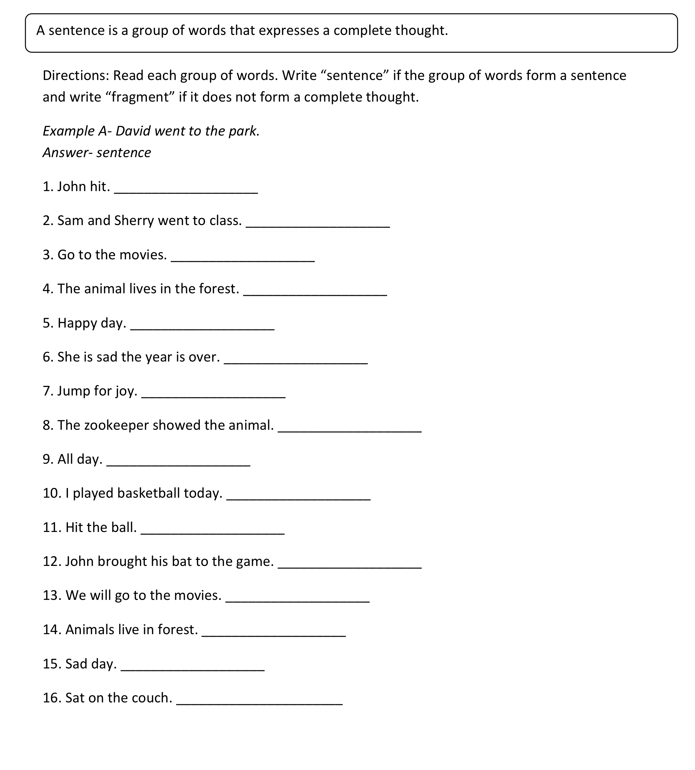



**The importance of understanding sentence patterns:**

We will use these sample paragraphs to show how we read and understand the text by looking at the units of meaning. Note the clauses and the phrases that add information to the basic simple sentence. We will learn to build sentences like these this term.

**Pratice 1**

*Look at the paragraph below. It describes a cat. Add the appropriate punctuation marks and give it a* ***meaningful*** *title.*

Title: ______________________________________

|  |
| --- |
| i have a cat she is brown my cat likes to sit on the mat she will run up a tree if a dog runs after her my cat likes to sit on my bed i like to hug her she can jump when she runs after a bird i saw a red bird that my cat jumped on but the bird got away my dog will run after her when she jumps on a bird i am glad the bird got away it is good to have cat my cat makes me feel happy. |

**Pratice 2**

*Take look at the paragraph below. It tells us about sandwiches. Add the appropriate punctuation marks and give it a title.*

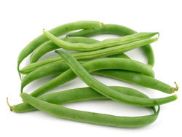 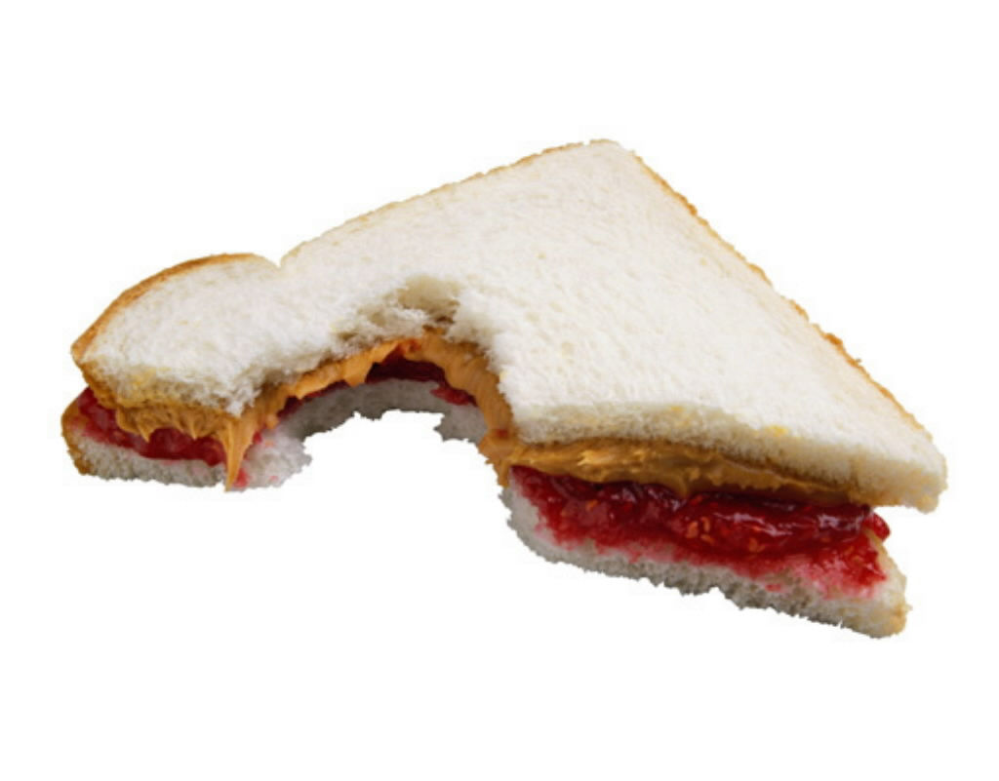

Title: __________________________________________

|  |
| --- |
| Have you ever had a string bean sandwich most students would not want that for lunch what is the favorite sandwich in American school lunches if you said peanut butter and jelly you would be right other popular sandwiches are ham and bologna cheese is the fourth favorite sandwich many students also like turkey sandwiches. |